

Hands-on Exercise
Gather Internet of Things sensor data using Bluemix and Node-RED.

Develop your first Bluemix app workshop 2016

Contents

Introduction 3
Step 0. Visualizing Mobile Sensor Data using IBM Internet of Things Foundation 4
Step 1. Create Your Node-RED Application 6
Step 2. Connecting Your Device to IBM Internet of Things Foundation 8
Step 3. Create your Node-RED flow. 9
Step 4. Adding further functionality to your Node-RED flow. 11
Step 5. Using Your Phone’s Data to Send Twitter Messages 13
Step 6. Use Twitter Data as Input for a Sentiment Analysis 16

Introduction
This exercise will show you how to deploy an application from the IBM Bluemix Web User Interface. We will create a Node-RED application running on SDK for Node.js runtime. Bluemix and Node-RED will be used to collect sensor data from a mobile device. We will then set up the application to send messages to Twitter based on the real time sensor information from the mobile device. To end things off, we will use IoT foundation to create a real-time sentiment analysis of twitter feeds.
About IBM Bluemix
Bluemix is an open-standard, cloud-based platform for building, managing, and running applications of all types (web, mobile, big data, new smart devices, and so on).
- The developer can choose any language runtime or bring their own. Zero to production in one command.
- A catalog of IBM, third party, and open source API services allow the developer to stitch an application together in minutes.
- Development, monitoring, deployment, and logging tools allow the developer to run the entire application.
- Sign up in minutes. Pay as you go and subscription models offer choice and flexibility.

About Node-RED
Node-RED is a visual tool for wiring the internet of things – connecting hardware devices, APIs and online services in a new and interesting way. Node-RED provides a browser-based flow editor that makes it easy to wire together flows using the wide range nodes in the palette. Flows can be then deployed to the runtime in a single-click.
- JavaScript functions can be created within the editor using a rich text editor.
- A built-in library allows you to save useful functions, templates or flows for re-use.
- See https://nodered.org for more information.
Prerequisites
- Register on IBM Bluemix at https://bluemix.net

Step 0. Visualizing Mobile Sensor Data using IBM Internet of Things Foundation
- Before we begin with the main lab (starting in Step 1), we will visualize sensor data from a mobile device using IBM Internet of Things foundation quick start. We will then create our own Bluemix application to import sensor data and show how you can act on the data in real-time.
- We will first set up your mobile device to send its sensor data to the IBM Internet of Things Foundation. Open a browser on your mobile device and go to
http://phonesensor.mybluemix.net
If you get a connection-failed message, make sure there is no s after http.
- Copy or write down the set of numbers presented after “d:quickstart:phone-sensor:”. This will be needed in the next step.
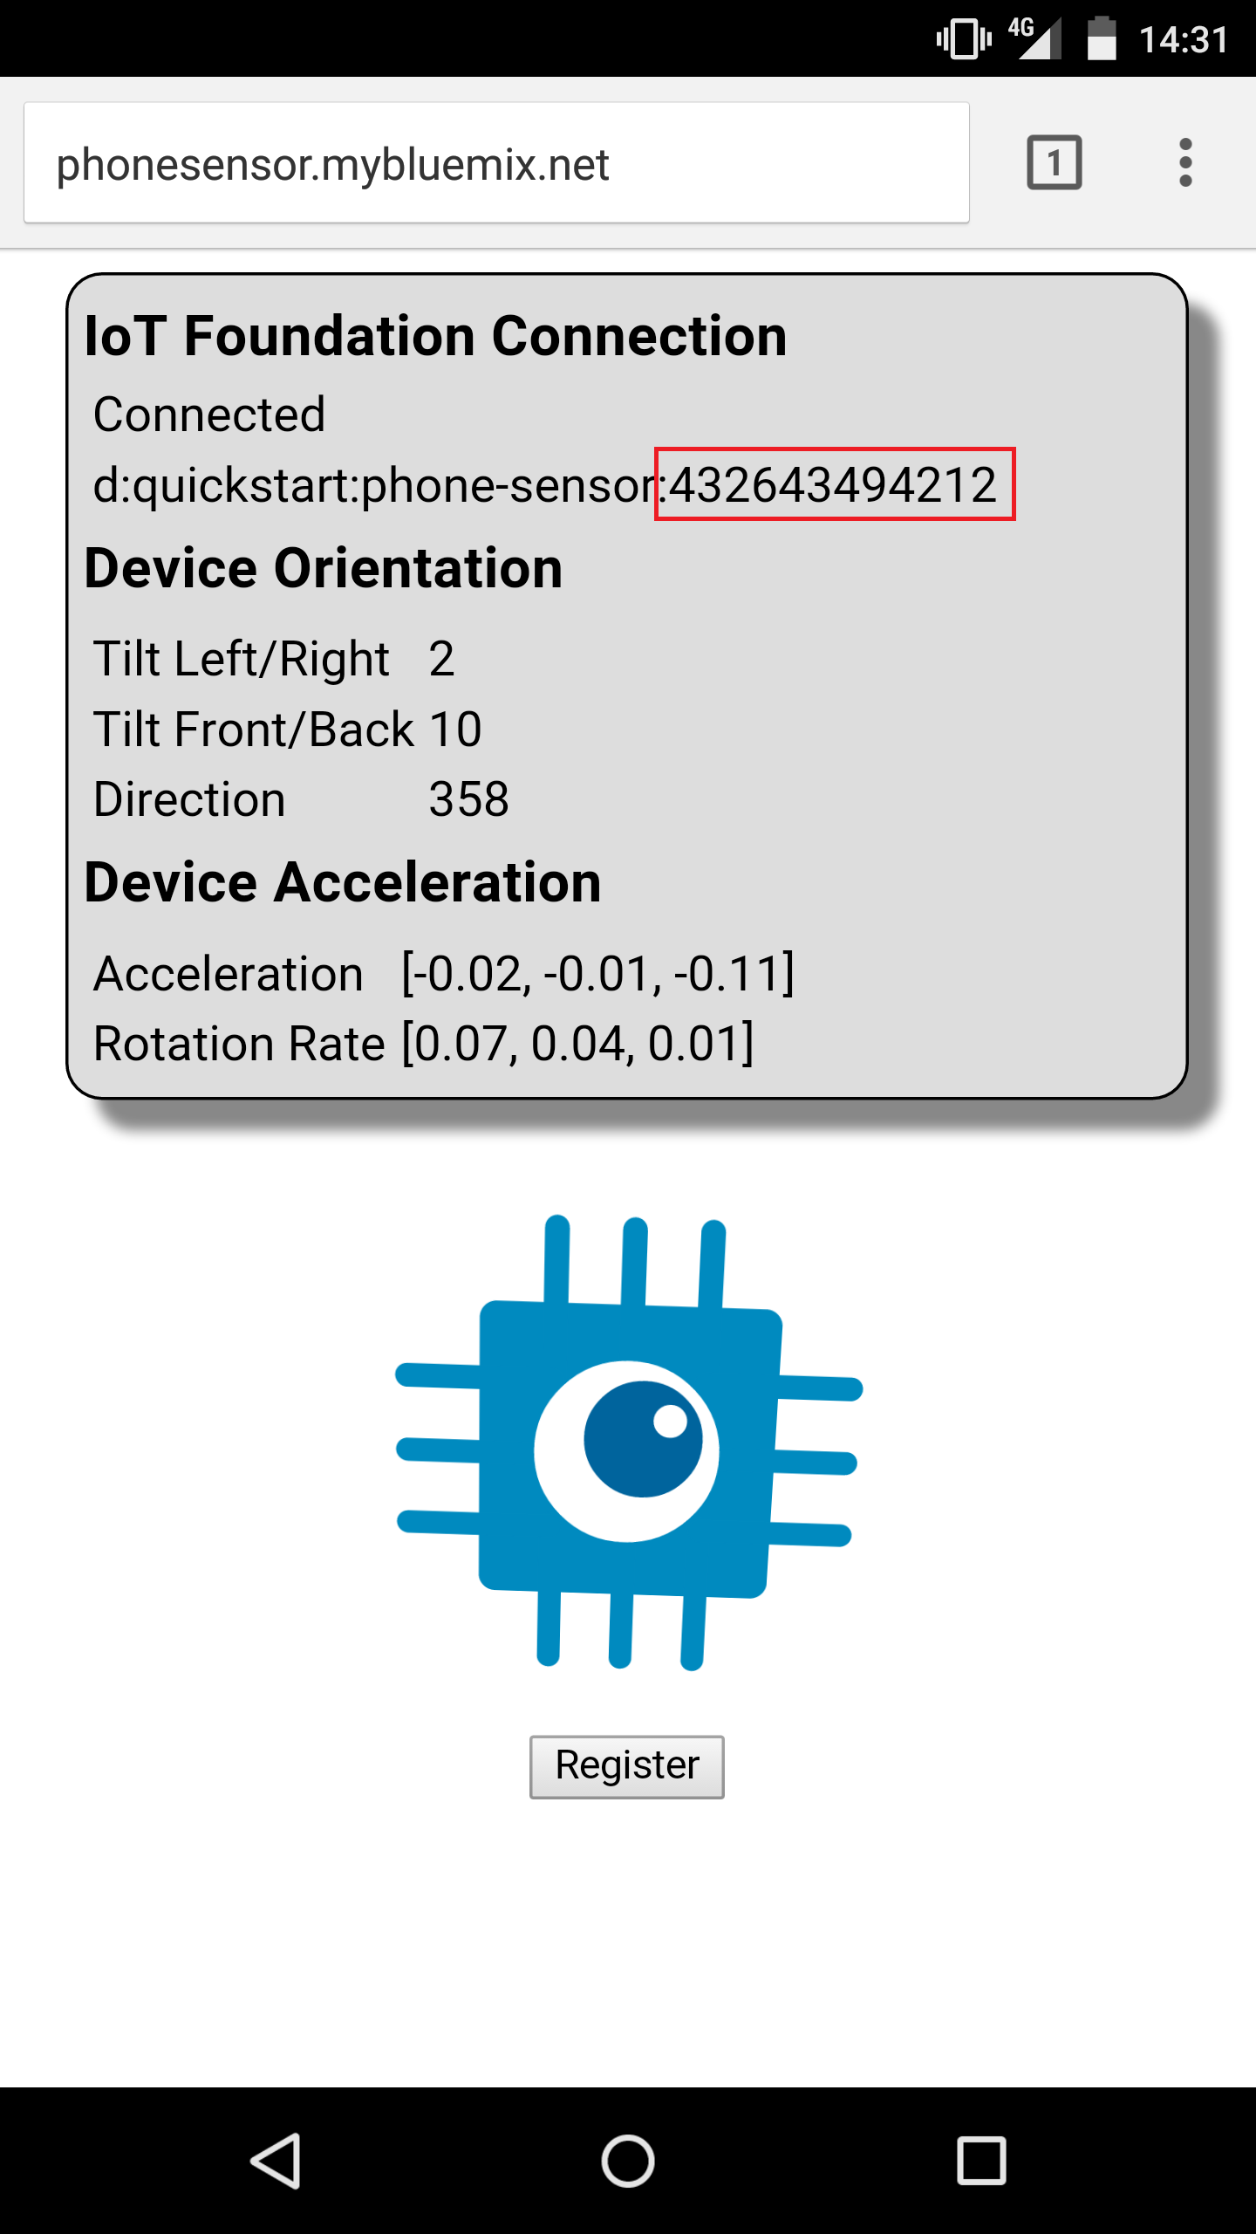
- Open a new browser on your computer and navigate to https://quickstart.internetofthings.ibmcloud.com/#/
- Enter the set of numbers you wrote down / copied in step 3 and click on ‘GO’.
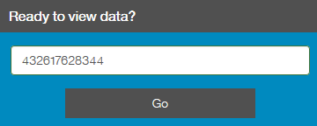
- Make sure you keep the browser with https://phonesensor.mybluemix.net open on your phone and watch the sensor data flow in the IBM Internet of Things Foundation quick start window. Try moving your phone and selecting the different phone sensors.
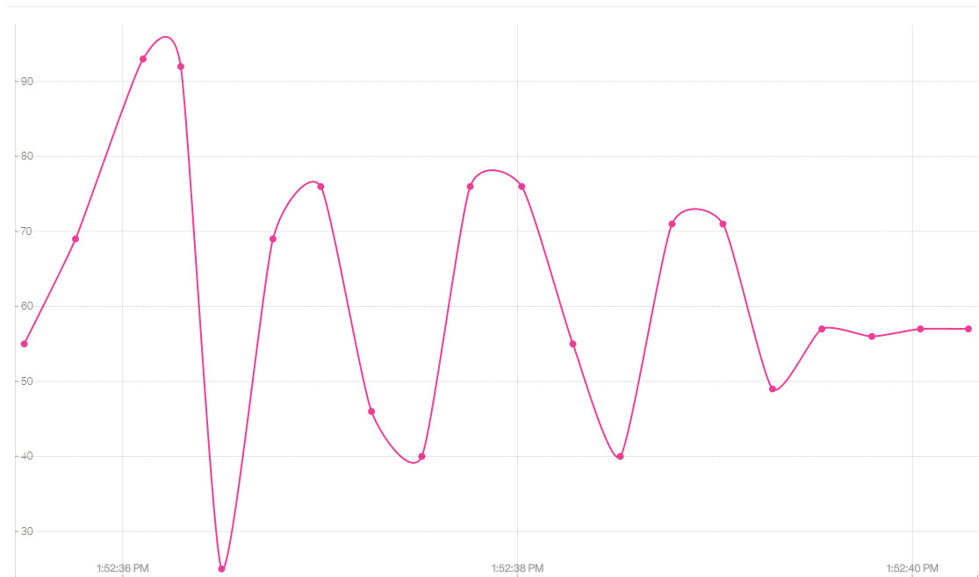
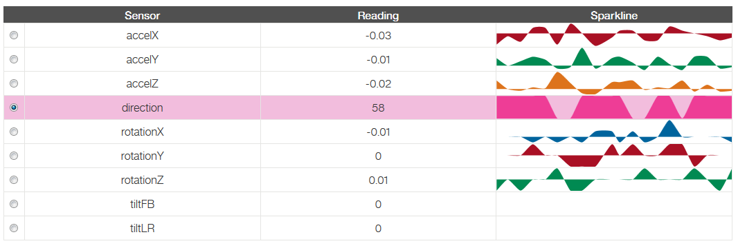

Step 1. Create Your Node-RED Application
- In a browser navigate to https://bluemix.net
- Select ‘LOG IN’ then enter your log in information and press ‘SIGN IN’. You should be seeing your dashboard view:
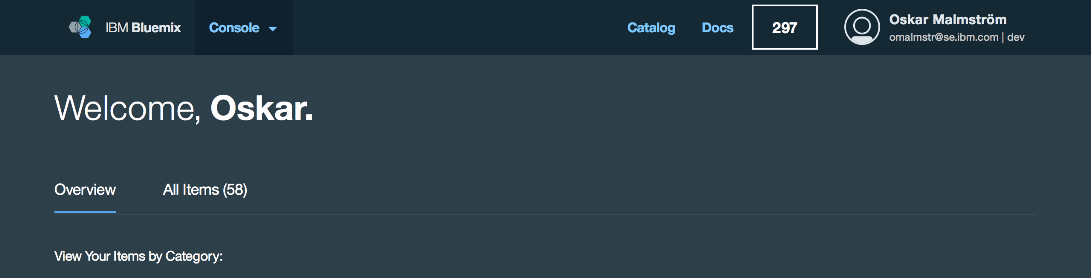
- Select the ‘CATALOG’ view.
- Locate the NODE-RED Starter in the boilerplate section of the catalog and click on it. Make sure your ‘REGION’ is set to ‘United Kingdom’ in the upper right corner (click on icon in the upper right corner).
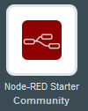
- Enter a name for your application, as shown below (host will automatically be completed). The host name must be unique on Bluemix, so please choose a name with your company name or initials to try to make a unique name. Scroll down and press ‘CREATE’ . 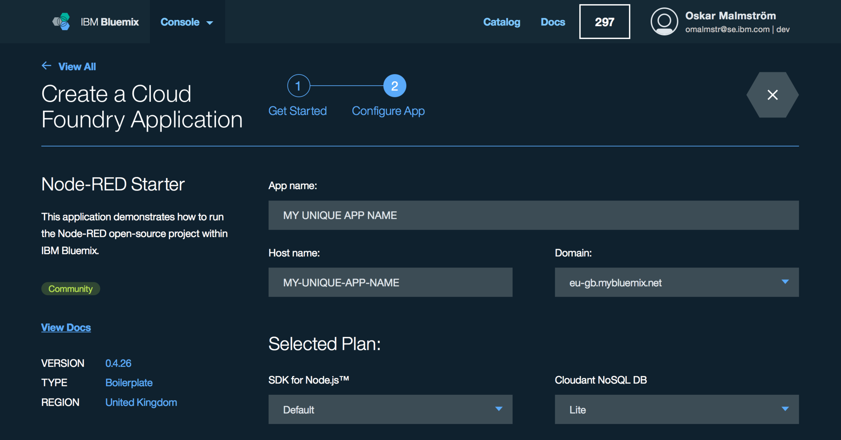

- Your application is now staging and will be up and running in a short while. Press ‘OVERVIEW’ to see information about your application.
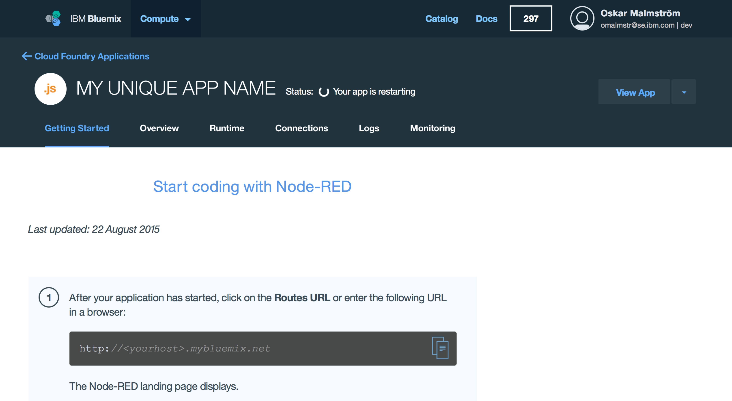

- When fully staged, press the View app in the upper right corner for your application, this launches the Node-RED main page.
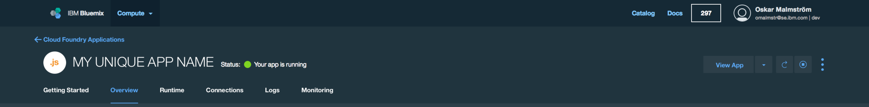
- Now click Go to your Node-RED flow editor to open the flow editor.
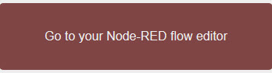
- When using Node-RED we build our apps using this graphical editor interface to wire together the blocks we need. We can simply drag and drop the blocks from the left menu into the workspace in the center of the screen and connect them to create a new flow.

Step 2. Connecting Your Device to IBM Internet of Things Foundation
- If you completed Step 0. you may skip this step.
Before we begin creating our flow in Node-RED, we will first set up your mobile device to send its sensor data to the IBM Internet of Things Foundation from which we will be able to extract data from within Node-RED. Open a browser on your mobile device and go to http://phonesensor.mybluemix.net.
- Copy or write down the set of numbers presented after “d:quickstart:phone-sensor:”. This will be needed in the next step.

Step 3. Create your Node-RED flow.
- Locate the ibmiot node under the input section in the palette window.
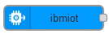
- Drag the node onto the workspace in the middle of the screen.
- Double click on your new ibmiot node and select ‘QUICKSTART’ under ‘AUTHENTICATION’.
- Enter the set of numbers you wrote down / copied in Step 0. or Step 2. in ‘DEVICE ID’. Press ‘OK’.
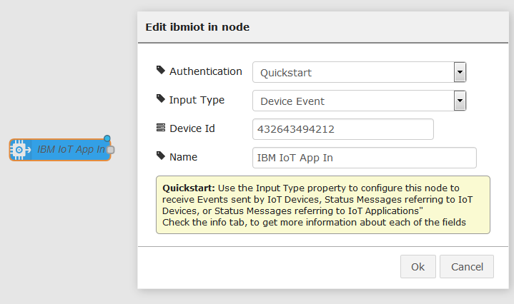
- Locate the debug node under the output section in the palette window.
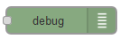
- Drag the node onto the workspace.
- Connect the ibmiot node with the debug node by dragging the output and input dots together.
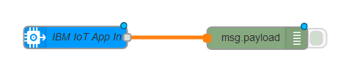
- Click ‘DEPLOY’ in the upper right corner.
- Click on the “debug” tab on the right of the screen to see the phone sensor data flowing. Make sure you have the phone sensor browser tab open on your phone. The web application is only sending sensor data to Bluemix as long as the browser is kept open and the screen is on. Try moving your phone up/down or sideways to see the sensor data changing in real time.
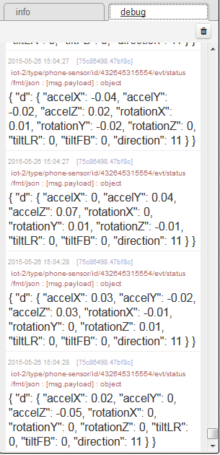

Step 4. Adding further functionality to your Node-RED flow.
- Delete the connection between the ibmiot node and the debug node.
- Add a function node under function in the palette window between the ibmiot node and the debug node.
- In the function node, add the following code:
if (parseFloat(msg.payload.d.tiltFB) > 45) {
msg.payload = "Phone rotated more than 45 degrees";
} else return;
return msg;
This code will create the output “Phone rotated more than 45 degrees” in the debug tab if your phone is rotated more than 45 degrees. tiltFB is the tilt in the front-back direction of the phone.
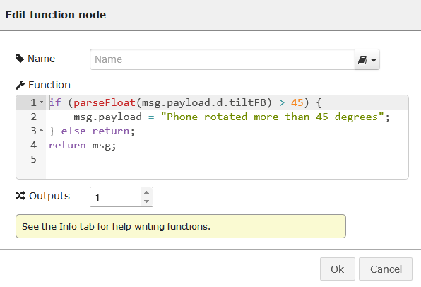
- Connect the ibmiot node to the function node, and the function node to the debug node.
- Click ‘DEPLOY’ and try rotating your phone in the front-back direction. Make sure the https://phonesensor.mybluemix.net browser is open. See what happens in the debug tab when the phone is rotated more than 45 degrees.
- You can try different functions and outputs by editing the function node. The different sensors are sent through the following payloads:
- msg.payload.d.accelX
- msg.payload.d.accelY
- msg.payload.d.accelZ
- msg.payload.d.rotationX
- msg.payload.d.rotationY
- msg.payload.d.rotationZ
- msg.payload.d.tiltFB
- msg.payload.d.tiltLR
- msg.payload.d.direction

Step 5. Using Your Phone’s Data to Send Twitter Messages
- Node-RED can be set up to send Twitter messages based on the incoming sensor data.
- Go to https://twitter.com and make sure you are signed into your Twitter account. If you do not have a Twitter account, go to https://twitter.com and sign up for free.
- In your Node-RED window, ‘DELETE’ the debug node.
- Add a delay node found under functions in the palette window. We need this node to make sure only one Tweet is posted. Without this node, the same message would be posted over and over again on Twitter.
- Double click on the delay node and change the ‘ACTION’ to ‘Limit rate to’ and the ‘RATE’ to ‘1 msg(s) per Day’.
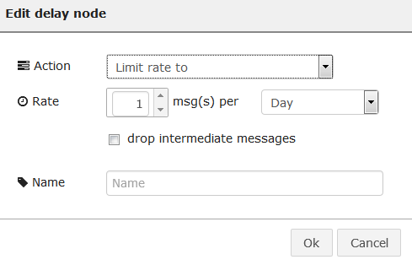
- Finally, add a Twitter out node found under social in the palette window.
- Double click on the Twitter out node and click on the edit button next to ‘Add new twitter-credentials’.
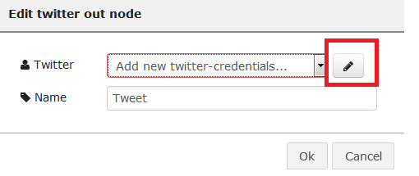
- Click on ‘Click here to authenticate with Twitter.’
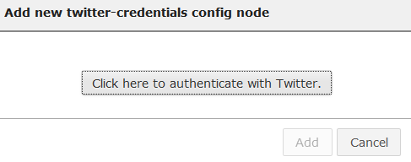
- This will open a new browser tab, click on ‘Authorize app’. You should receive the message ‘Authorised - you can close this window and return to Node-RED’. Close the browser tab.
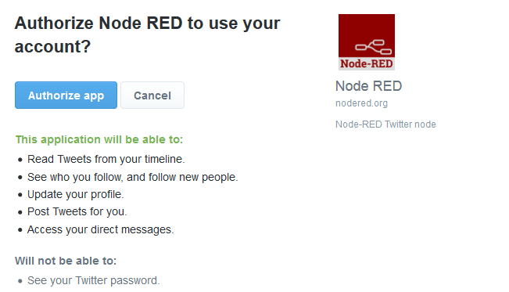

- Go back to your Node-RED tab. You should now see your Twitter username next to the Twitter ID. Click ‘ADD’. You are now done setting up the connection to Twitter. Click ‘OK’.
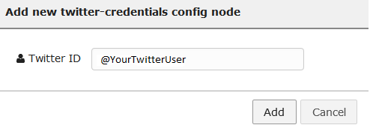
- Connect all your nodes, it should look like this:
- When you rotate your phone (with the phone sensor browser tab open) more than 45 degrees it will post a message to Twitter.

Step 6. Use Twitter Data as Input for a Sentiment Analysis
- We will now create a flow that instead of posting to Twitter based on input data, we gather data from twitter, analyze the sentiment of the data data and send the data through the IoT foundation to a live graph.
- ‘DELETE’ your previous flow.
- Create the following flow:
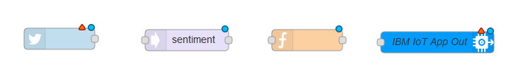
1. Twitter node found under ‘Social’.
2. Sentiment node found under ‘Analysis’.
3. Function node found under ‘function’.
4. IoT Out node found under ‘output’.

- Click on the Twitter node. If needed, add your credentials like done in the previous step. Configure the node like the picture below, where ‘for’ can be any key word that gets a lot of twitter posts (for example IBM or Google).
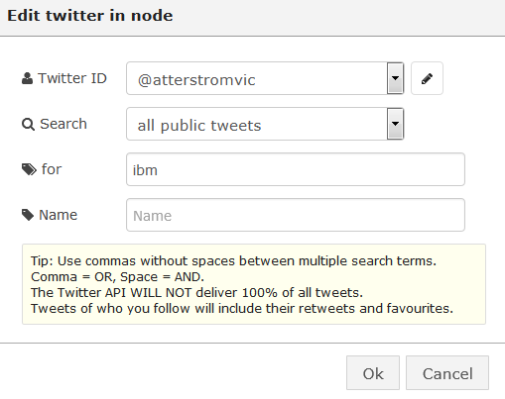

- Add the following code to the function node:
//This code creates a JSON array based on the data from the previous node. We extract the relevant information, like the tweet, the sentiment score, the location of the tweet and the number of followers.
msg.payload = JSON.stringify({
d: {
Description: "All tweets with a connection to your keyword",
Sentiment: msg.sentiment.score,
Tweet: msg.payload,
Location: msg.location,
Followers: msg.tweet.user.followers_count
}
});
return msg;
- Configure the IoT Out node like the picture below, where ‘Device Id’ is a unique name of your choice, for example your first name. This name is not linked to the device id used in the previous exercise. The value in ‘Data’ is not important, as this node is programmed so that any information sent from the previous node in msg.payload will override the value of ‘Data’.
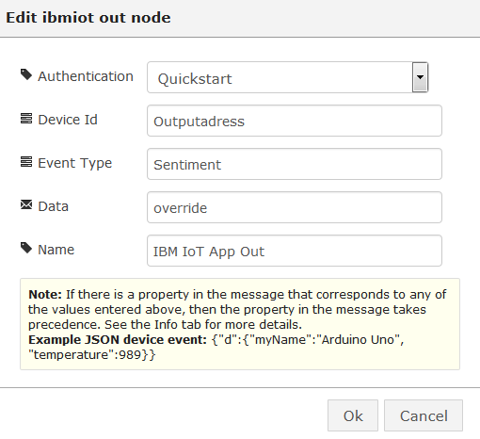
- Connect your flow together:
- Go to https://quickstart.internetofthings.ibmcloud.com/ and enter your unique device ID, entered in step 6. You should now be seeing a graph with a live flow of the sentiment analysis of your chosen keyword. Anything below 0 is a negative sentiment, 0 is neutral, and anything above 0 is positive.

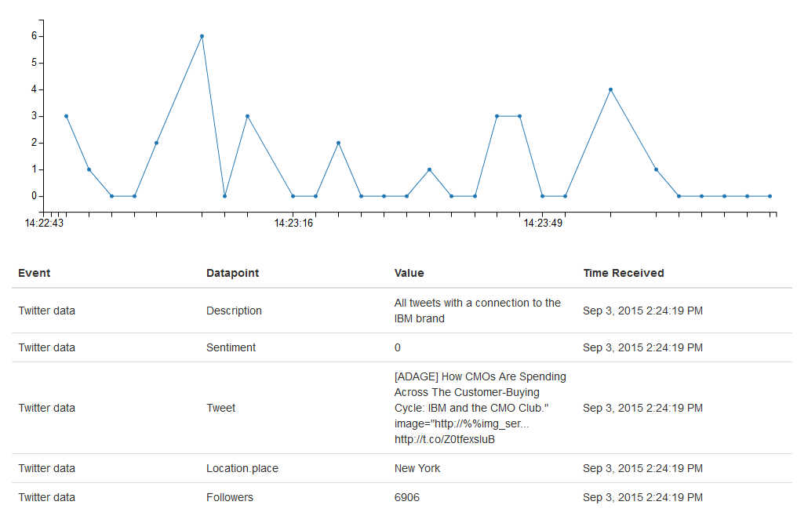

Congratulations! You’ve successfully completed this lab where you've deployed a Bluemix application and used Node-RED to act on IoT sensor and twitter data.

